**Alpha Classes**

**http://www.alphaclasses.com**

**+91-8146463753**

Chemistry

**Alpha Classes**

# Organic Chemistry

`

## Haloalkanes

The replacement of hydrogen atom(s) in an aliphatic hydrocarbon, by halogen atom(s) results in the formation of alkyl halide (haloalkane) Haloalkanes contain halogen atom(s) attached to the *sp3* hybridised carbon atom of an alkyl group.

**Classification**

**1.) On the Basis of Number of Halogen Atoms**

These may be classified as mono, di, or polyhalogen (tri-,tetra-, etc.) compounds depending on whether they contain one, two or more halogen atoms in their structures. For example,



**2.) Compounds Containing *sp3* C—X Bond (X= F, Cl, Br, I)**

***(a) Alkyl halides or haloalkanes (R—X)***

In alkyl halides, the halogen atom is bonded to an alkyl group (R). They form a homologous series represented by CnH2n+1X. They are further classified as primary, secondary or tertiary according to the nature of carbon to which halogen is attached.



***(b) Allylic halides***

These are the compounds in which the halogen atom is bonded to an *sp3*-hybridised carbon atom next to carbon-carbon double bond (C=C) *i.e.* to an allylic carbon.





***(c) Benzylic halides***

These are the compounds in which the halogen atom is bonded to an *sp3*-hybridised carbon atom next to an aromatic ring.



3.) **Compounds Containing *sp2* C—X Bond**

This class includes:

***(a) Vinylic halides***

These are the compounds in which the halogen atom is bonded to an *sp2*-hybridised carbon atom of a carbon-carbon double bond (C = C).



***(b) Aryl halides***

These are the compounds in which the halogen atom is bonded to the sp2-hybridised carbon atom of an aromatic ring.



**4.) Dihaloalkanes**

***(a) Vicinal dihalides***

Contain both halogens on adjacent carbon atoms. There Common name is **Alkylene Dihalides**.







Ethylene Dichloride Propylene Dibromide Butylene dibromide

***(b) Gem dihalides***

The two halogens are present on the same carbon atom. Their common name is **Alkylidene Dihalides**.

CH3-CHBr2 Ethylidene Dibromide

CH3CH2CHBr2 n-propylidene dibromide



Isopropylidene dibromide

**5.) Trihaloalkanes**

CHCl3 Chloroform

CHBr3 Bromoform

CHI3 Iodoform

CHF3 Fluoroform

**6.) Tetrahaloalkanes**

CCl4 Carbom tetrachloride (Pyrene) {Tetrachloromethane}

**6.) Polyhaloalkanes**

C2Cl6 Hexachloroethane

Nomenclature

The common names of alkyl halides are derived by naming the alkyl group followed by the halide. Alkyl halides are named as halosubstituted hydrocarbons in the IUPAC system of nomenclature. Haloarenes are the common as well as IUPAC names of aryl halides. For dihalogen derivatives, the prefixes *o*-, *m*-, *p-* are used in common system but in IUPAC system, the numerals 1,2; 1,3 and 1,4 are used.





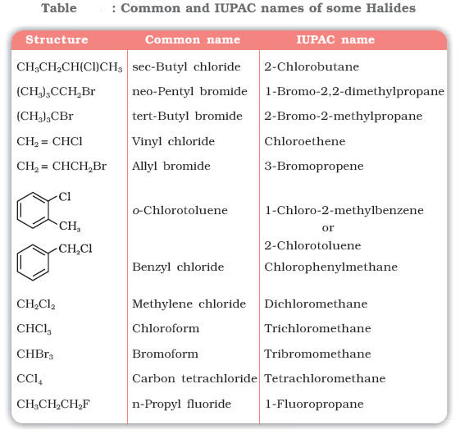

Q. Draw the structures of all the eight structural isomers that have the molecular formula C5H11Br. Name each isomer according to IUPAC system and classify them as primary, secondary or tertiary bromide. **( NCERT)**

Q. Write IUPAC names of the following: **( NCERT)**





Q **( NCERT)** .

Nature of C-X Bond

Since halogen atoms are more electronegative than carbon, the carbonhalogen bond of alkyl halide is polarised; the carbon atom bears a partial positive charge whereas the halogen atom bears a partial negative charge.

Since the size of halogen atom increases as we go down the group in the periodic table, fluorine atom is the smallest and iodine atom, the largest. Consequently the carbon-halogen bond length also increases

from C—F to C—I.



Physical Properties

Boiling Point

* Because of their greater molecular weights, haloalkanes have considerably higher boiling points than alkanes with the same number of carbons.
* For a given alkyl group, the boiling point increases with increasing atomic weight of the halogen, so that a fluoride is the lowest boiling, an Iodide the highest boiling.
* For a given halogen, the boiling point rises with increasing carbon number.The boiling point rise is 20-30 degrees for each added carbon.
* Branching involving either the alkyl groups or the halogen itself –lowers the boiling point.

Solubility

* The haloalkanes are only very slightly soluble in water. In order for a haloalkane to dissolve in water, energy is required to overcome the attractions between the haloalkane molecules and break the hydrogen bonds between water molecules. Less energy is released when new attractions are set up between the haloalkane and the water molecules as these are not as strong as the original hydrogen bonds in water. As a result, the solubility of haloalkanes in water is low. However, haloalkanes tend to dissolve in organic solvents because the new intermolecular attractions between haloalkanes and solvent molecules have much the same strength as the ones being broken in the separate haloalkane and solvent molecules.

Q. Arrange each set of compounds in order of increasing boiling points. NCERT

(i) Bromomethane, Bromoform, Chloromethane, Dibromomethane.

(ii) 1-Chloropropane, Isopropyl chloride, 1-Chlorobutane.

Methods of Preparation

1. **Grove's process**: ***Reaction of alcohol with Lucas Reagent: (conc. HCI + anhyd. ZnCl***)

This reaction is used to test pri, sec, & tert alcohol. 30 alcohols reacts instantaneously & give turbidity due to formation of insoluble chloride. 2o alcohols react to give turbidity after 5 min. whereas 1o alcohols give no turbidity as there is no reaction at room temperature.

This test is applicable only for lower alcohols which are water soluble. It is because alcohols having more than 6 carbon are almost insoluble in water hence two immiscible liquid is present before the addition of Lucas Reagent, so the presence of alkyl halide can't be detected properly.

In this process replacement "OH" group in primary and secondary alcohols with an "X” atom by means of Hydrogen chloride or bromide in presence of Zinc chloride. But for tertiary alcohol readily react with concentrated hydrochloric acid in the absence of zinc chloride. Zinc chloride is a lewis acid and consequently can co-ordinate with the alcohol



The R-O bond is weakened and so the complex readily forms a carbonium ion (SN1 mechanism). If the nature of R+ is such that it can ,undergo rearrangement the product will be mixture of isomeric alkyl chlorides.

The reaction also follows S2 mechanism when the concentration of zinc chloride is low, the reaction is still catalysed, but no rearrangement occurs.



* Pyridine and dimethyl amine also catalyse the reaction between alcohols and hydrochloric acid without rearrangement

To avoid rearrangement or to make this reaction SN2. **Tosylation** process can be used, - OTs

is a weak nucleophile & better leaving group. Due to its bulkyness it prefers SN2 reaction by

backside attack of nucleophile.





* For alkyl iodide a non oxidising acid is used along with KI [HI is not preferred as it is a good reducing agent]



Q . Why is sulphuric acid not used during the reaction of alcohols with KI? **(NCERT)**

Q. What happens when neopentyl alcohol reacts with anhydrous hydrogen bromide?



2. **Darzen’s Process.** Thionyl chloride reacts with straight-chain primary alcohols without

rearrangement in the presence or absence of pyridine the reaction proceeds via a

chloro sulphite

Mechanism



3. With **PCl5**



If R group is tertiary, It will be SN1 reaction which takes place via recamization (via carbocation formation). Rearrangement also takes place.

4. **Reaction with phosphorus Halide.**

This reaction takes place via SN2 without rearrangement and via inversion of configuration.

[Only with 3o alcohol reaction is SN1 & nucleophile can attack from either ends on carbocation

to give a racemic mixture].

3ROH + PCI3 -----> RCI + H3PO3



Phosphorus tribromide and triiodide are usually generated *in situ* (produced in the reaction mixture) by the reaction of red phosphorus with bromine and iodine respectively.

r



5. **By Free Radical Halogenation**

Detailed Mechanism (Free radical Substitution Reaction)

1. Initiation Step

It is the hemolytic cleavage of chlorine molecule to chlorine free radical by absorbing energy when Cl2 is subjected to UV light at room temperature.

2. Propagation step

a) The chlorine free radical attacks the alkane molecule , abstracts a hydrogen atom giving hydrogen chloride and alkyl free radical.

b) The alkyl free radical reacts further with a chlorine molecule forming alkyl chloride and chlorine free radical.

3. Termination Step.

In this step , the free radicals obtained during the propagation may combine to give products.

* Iodination of alkanes is slow and reversible process because of formation of strong reducing agent , hydrogen iodide , as a by- product which reduces iodoalkane back to alkane

CH4 + I2 ⇌ CH3I + HI

Thus direct iodination of alkane is not possible.

To get iododerivatives we use strong oxidizing agents like iodic acid (HIO3) ,periodic acid (HIO4) , nitric acid (HNO3) or mercuric oxide HgO which convert HI to I2 or destroy Iodide

5HI + HIO3 ----> 3 I2 + 3 H2O

2 HI + 2 HNO3 ----> I2 + 2 H2O + 2 NO2

2 HI + HgO ----> HgI2 + H2O

* Fluorination of alkanes is highly exothermic or explosive, hence it cannot be controlled under ordinary conditions. Further more , fluorination brings about extensive rupture of C-C and C-H bond leading to a mixture of fluoroproducts.

Q. Identify all the possible monochloro structural isomers expected to be formed on free radical monochlorination of (CH3)2CHCH2CH­3. **(NCERT)**

***6.) From alkenes***

(i) *Addition of hydrogen halides*: An alkene is converted to corresponding alkyl halide by reaction with hydrogen chloride, hydrogen bromide or hydrogen iodide.



Propene yields two products, however only one predominates as per Markovnikov’s rule.



Q.



NCERT

**7.) Halogen exchange**

**a) Finkelstein Reaction**

Alkyl iodides are often prepared by the reaction of alkyl chlorides/bromides with NaI in **dry acetone.**



NaCl or NaBr thus formed is precipitated in dry acetone. It facilitates the forward reaction according to Le Chatelier’s Principle.

**b) Swarts Reaction**

The synthesis of alkyl fluorides is done by heating an alkyl chloride/bromide in the presence of a metallic fluoride such as AgF, Hg2F2, CoF2 or SbF3.



Q. Write structures of different dihalogen derivatives of propane. NCERT

Q. Among the isomeric alkanes of molecular formula C5H12, identify the one that on photochemical chlorination yields NCERT

(i) A single monochloride.

(ii) Three isomeric monochlorides.

(iii) Four isomeric monochlorides.

Q .



NC

NCERT

8.) Borodine Hundsdiecker reaction

RCOOAg + Br2 ----> RBr + CO2 + AgBr

The yield of halide is primary> secondary> tertiary

Mechanism is through free radical formation:

RCOOAg + Br2 ----> RCOOBr + AgBr



## Reactions of Haloalkanes

## (i) *Nucleophilic substitution reactions*

## 



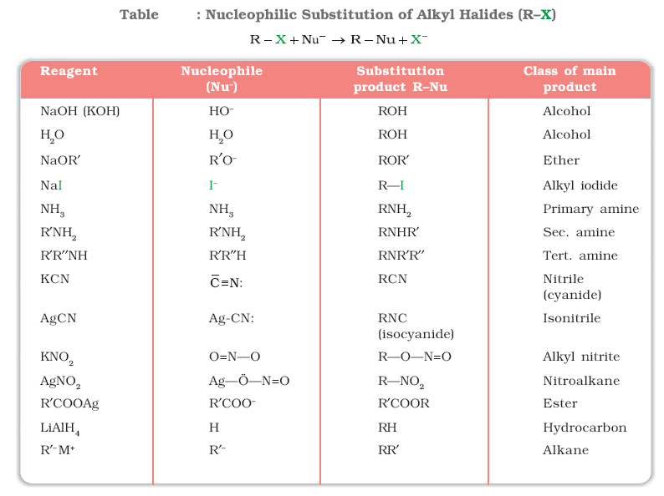

Groups like cyanides and nitrites possess two nucleophilic centres and are called ***ambident nucleophiles***. Actually cyanide group is a hybrid of two contributing structures and therefore can act as a nucleophile in two different ways [-C≡N ↔ :C=N-], *i.e.,* linking through carbon atom resulting in alkyl cyanides and through nitrogen atom leading to isocyanides. Similarly nitrite ion also represents an ambident nucleophile with two different points of linkage [–O—N=O]. The linkage through oxygen results in alkyl nitrites while through nitrogen atom, it leads to nitroalkanes.

Q. Haloalkanes react with KCN to form alkyl cyanides as main product while AgCN forms isocyanides as the chief product. Explain. **(NCERT)**

KCN is predominantly ionic and provides cyanide ions in solution.Although both carbon and nitrogen atoms are in a position to donateelectron pairs, the attack takes place mainly through carbon atom and

not through nitrogen atom since C—C bond is more stable than C—N bond. However, AgCN is mainly covalent in nature and nitrogen is freeto donate electron pair forming isocyanide as the main product.

***(a) Substitution nucleophilic bimolecular (SN2)***



The incoming nucleophile interacts with alkyl halide causing the carbonhalide bond to break while forming a new carbon-OH bond. These two processes take place simultaneously in a single step and no intermediate is formed. As the reaction progresses and the bond between the nucleophile and the carbon atom starts forming, the bond between carbon atom and leaving group weakens. As this happens, the configuration of carbon atom under attack inverts in much the same way as an umbrella is turned inside out when caught in a strong wind, while the leaving group is pushed away. This process is called as **inversion of configuration**. In the transition state, the carbon atom is simultaneously bonded to incoming nucleophile and the outgoing leaving group and such structures are unstable and cannot be isolated. This is because the carbon atom in the transition state is simultaneously bonded to five atoms and therefore is unstable. Tertiary halides are the least reactive because bulky groups hinder the approaching nucleophiles. Thus the order of reactivity followed is:

Primary halide > Secondary halide > Tertiary halide.

## *(b) Substitution nucleophilic unimolecular (SN1)*



It occurs in two steps. In step I, the polarised C—Br bond undergoes slow cleavage to produce a carbocation and a bromide ion. The carbocation thus formed is then attacked by nucleophile in step II

to complete the substitution reaction. Step I is the slowest and reversible. It involves the C–Br bond breaking for which the energy is obtained through solvation of halide ion with the proton of protic solvent. Since the rate of reaction depends upon the slowest step, the rate of reaction depends only on the concentration of alkyl halide and not on the concentration of hydroxide ion. Further, greater the stability of carbocation, greater will be its ease of formation from alkyl halide and faster will be the rate of reaction. In case of alkyl halides, 30 alkyl halides undergo SN1 reaction very fast because of the high stability of 30 carbocations.



## Allylic and benzylic halides show high reactivity towards the SN1 reaction. The carbocation thus formed gets stabilised through resonance



For a given alkyl group, the reactivity of the halide, R-X, follows the same order in both the mechanisms R–I> R–Br>R–Cl>>R–F.



Q

Q.



Q. Identify chiral and achiral molecules in each of the following pair of compounds.



In case of optically active alkyl halides, the product formed as a result of SN2 mechanism has the inverted configuration as compared to the reactant. This is because the nucleophile attaches itself on the side opposite to the one where the halogen atom is present. When (–)-2-bromooctane is allowed to react with sodium hydroxide, (+)-octan-2-ol is formed with the –OH group occupying the position opposite to what bromide had occupied.



Thus, SN2 reactions of optically active halides are accompanied by inversion of configuration.

In case of optically active alkyl halides, SN1 reactions are accompanied by racemisation. Actually the carbocation formed in the slow step being *sp2* hybridised is planar (achiral). The attack of the nucleophile may be accomplished from either side resulting in a mixture of products, one having the same configuration (the –OH attaching on the same position as halide ion) and the other having opposite configuration (the –OH attaching on the side opposite to halide ion). This may be illustrated by hydrolysis of optically active 2-bromobutane, which results in the formation of (±)-butan-2-ol.



## *2. Elimination reactions*



Saytzeff Rule

“*in dehydrohalogenation reactions, the preferred product is that alkene which has the greater number of alkyl groups attached to the doubly bonded carbon atoms*.”

Thus, 2-bromopentane gives pent-2-ene as the major product.



***3. Reaction with metals***

**Grignard Reagents**.



These reagents are obtained by the reaction of haloalkanes with magnesium metal in dry ether.

In the Grignard reagent, the carbon-magnesium bond is covalent but highly polar, with carbon pulling electrons from electropositive magnesium; the magnesium halogen bond is essentially ionic.

Grignard reagents are highly reactive and react with any source of proton to give hydrocarbons.



***Wurtz reaction***

Alkyl halides react with sodium in dry ether to give hydrocarbons containing double the number of carbon atoms present in the halide. This reaction is known as **Wurtz reaction.**



***Wurtz-Fittig reaction***

A mixture of an alkyl halide and aryl halide gives an alkylarene when treated with sodium in dry ether and is called Wurtz-Fittig reaction.



***Fittig reaction***

Aryl halides also give analogous compounds when treated with sodium in dry ether, in which two aryl groups are joined together. It is called Fittig reaction.



Q.



Q.



Q.



## Aryl Halides

**Methods of Preparation**

***a)By electrophilic substitution***

Aryl chlorides and bromides can be easily prepared by electrophilic substitution of arenes with chlorine and bromine respectively in the presence of Lewis acid catalysts like iron or iron(III) chloride. The *ortho* and *para* isomers can be easily separated due to large difference in their melting points. Reactions with iodine are reversible in nature and require the presence of an oxidising agent (HNO3, HIO4) to oxidise the HI formed during iodination.



***(b) Sandmeyer’s reaction***

When a primary aromatic amine, dissolved or suspended in cold aqueous mineral acid, is treated with sodium nitrite, a diazonium salt is formed . Mixing the solution of freshly prepared diazonium salt with cuprous chloride or cuprous bromide results in the replacement of the diazonium group by –Cl or –Br.



Replacement of the diazonium group by iodine does not require the presence of cuprous halide and is done simply by shaking the diazonium salt with potassium iodide.



**Reactions of Haloarenes**

Aryl halides are extremely less reactive towards nucleophilic substitution reactions

The presence of an electron withdrawing group (-NO2) at *ortho*- and *para*-positions increases the reactivity of haloarenes.

The effect is pronounced when (-NO2) group is introduced at *ortho* and *para*- positions. However, no effect on reactivity of haloarenes is observed by the presence of electron withdrawing group at *meta*-position. Mechanism of the reaction is as depicted:



***2. Electrophilic substitution reactions***

Haloarenes undergo the usual electrophilic reactions of the benzene ring such as halogenation, nitration, sulphonation and Friedel-Crafts reactions. Halogen atom besides being slightly deactivating is *o, p*directing; therefore, further substitution occurs at *ortho-* and *para*positions with respect to the halogen atom. The *o, p*-directing influence of halogen atom can be easily understood if we consider the resonating structures of halobenzene



Due to resonance, the electron density increases more at *ortho-* and *para*-positions than at *meta*-positions. Further, the halogen atom because of its –I effect has some tendency to withdraw electrons from the benzene ring. As a result, the ring gets somewhat deactivated as compared to benzene and hence the electrophilic substitution reactions in haloarenes occur slowly and require more drastic conditions as compared to those in benzene.





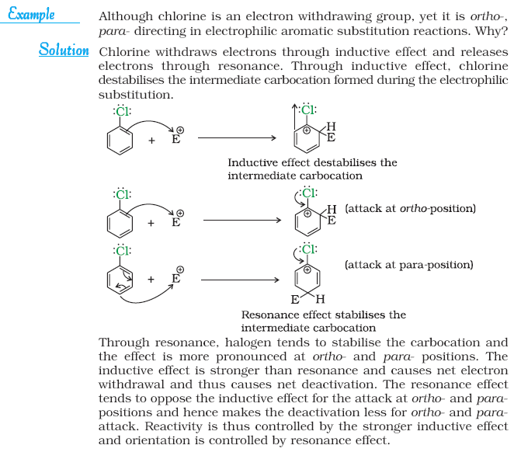

## NCERT Exercise



Q.

Q.



Q.



**Q 4** Which one of the following has the highest dipole moment?

(i) CH2Cl2 (ii) CHCl3 (iii) CCl4

**Q 5** A hydrocarbon C5H10 does not react with chlorine in dark but gives a single monochloro compound C5H9Cl in bright sunlight. Identify the hydrocarbon.

**Q.6** Write the isomers of the compound having formula C4H9Br.

**Q.7** Write the equations for the preparation of 1-iodobutane from

(i) 1-butanol (ii) 1-chlorobutane (iii) but-1-ene.

**Q.8** What are ambident nucleophiles? Explain with an example.

**Q.9** Which compound in each of the following pairs will react faster in SN2 reaction

with –OH?

(i) CH3Br or CH3I (ii) (CH3)3CCl or CH3Cl

**Q.10** Predict all the alkenes that would be formed by dehydrohalogenation of the following halides with sodium ethoxide in ethanol and identify the major alkene:

(i) 1-Bromo-1-methylcyclohexane (ii) 2-Chloro-2-methylbutane

(iii) 2,2,3-Trimethyl-3-bromopentane.

**Q.11** How will you bring about the following conversions?

(i) Ethanol to but-1-yne (ii) Ethane to bromoethene (iii) Propene to

1-nitropropane (iv) Toluene to benzyl alcohol (v) Propene to propyne

(vi) Ethanol to ethyl fluoride (vii) Bromomethane to propanone (viii) But-1-ene

to but-2-ene (ix) 1-Chlorobutane to n-octane (x) Benzene to biphenyl.

**Q.12** Explain why

(i) the dipole moment of chlorobenzene is lower than that of cyclohexyl chloride?

(ii) alkyl halides, though polar, are immiscible with water?

(iii) Grignard reagents should be prepared under anhydrous conditions?

Q.



Q. Write the mechanism of the following reaction:



Q 17 Arrange the compounds of each set in order of reactivity towards SN2 displacement:

(i) 2-Bromo-2-methylbutane, 1-Bromopentane, 2-Bromopentane

(ii) 1-Bromo-3-methylbutane, 2-Bromo-2-methylbutane, 3-Bromo-2-methylbutane

(iii) 1-Bromobutane, 1-Bromo-2,2-dimethylpropane, 1-Bromo-2-methylbutane,1-Bromo-3-methylbutane.

**Q.17** Out of C6H­5CH2Cl and C6H5CHClC6H5, which is more easily hydrolysed by aqueous KOH?

**Q.18** *p*-Dichlorobenzene has higher m.p. and solubility than those of *o*- and *m*-isomers.

Discuss.

**Q.19** How the following conversions can be carried out?

(i) Propene to propan-1-ol

(ii) Ethanol to but-1-yne

(iii) 1-Bromopropane to 2-bromopropane

(iv) Toluene to benzyl alcohol

(v) Benzene to 4-bromonitrobenzene

(vi) Benzyl alcohol to 2-phenylethanoic acid

(vii) Ethanol to propanenitrile

(viii) Aniline to chlorobenzene

(ix) 2-Chlorobutane to 3, 4-dimethylhexane

(x) 2-Methyl-1-propene to 2-chloro-2-methylpropane

(xi) Ethyl chloride to propanoic acid

(xii) But-1-ene to n-butyliodide

(xiii) 2-Chloropropane to 1-propanol

(xiv) Isopropyl alcohol to iodoform

(xv) Chlorobenzene to *p*-nitrophenol

(xvi) 2-Bromopropane to 1-bromopropane

(xvii) Chloroethane to butane

(xviii) Benzene to diphenyl

(xix) *tert*-Butyl bromide to isobutyl bromide

(xx) Aniline to phenylisocyanide

**Q.20** The treatment of alkyl chlorides with aqueous KOH leads to the formation of alcohols but in the presence of alcoholic KOH, alkenes are major products. Explain.

**Q.21** Primary alkyl halide C4H9Br (a) reacted with alcoholic KOH to give compound (b). Compound (b) is reacted with HBr to give (c) which is an isomer of (a). When (a) is reacted with sodium metal it gives compound (d), C8H18 which is different from the compound formed when n-butyl bromide is reacted with sodium. Give the structural formula of (a) and write the equations for all the reactions.

**Q.22** What happens when

(i) n-butyl chloride is treated with alcoholic KOH,

(ii) bromobenzene is treated with Mg in the presence of dry ether,

(iii) chlorobenzene is subjected to hydrolysis,

(iv) ethyl chloride is treated with aqueous KOH,

(v) methyl bromide is treated with sodium in the presence of dry ether,

(vi) methyl chloride is treated with KCN?

## Alcohols

**Alcohols** and **phenols** are formed when a hydrogen atom in a hydrocarbon, aliphatic and aromatic respectively, is replaced by –OH group.

The subsitution of a hydrogen atom in a hydrocarbon by an alkoxy or aryloxy group (R–O/Ar–O) yields another class of compounds known as ‘**ethers**’

**Classification**

***Mono, Di, Tri or Polyhydric Compounds***

Alcohols and phenols may be classified as mono–, di–, tri- or polyhydric compounds depending on whether they contain one, two, three or many hydroxyl groups



1. *Compounds containing* C *sp* 3 −OH *bond:*

In this class of alcohols, the –OH group is attached to an sp3hybridised carbon atom of an alkyl group. They are further classified as follows:

*Primary, secondary and tertiary alcohols:* In these three types of alcohols, the –OH group is attached to primary, secondary and tertiary carbon atom.



1. *Compounds containing* C *sp* 2 −OH *bond:*

These alcohols contain —OH group bonded to a carbon-carbon double bond i.e., to a vinylic carbon or to an aryl carbon. These alcohols are also known as vinylic alcohols.



**Ethers**

Ethers are classified as **simple** or **symmetrical**, if the alkyl or aryl groups attached to the oxygen atom are the same, and **mixed** or **unsymmetrical**, if the two groups are different. Diethyl ether, C2H5OC2H5, is a symmetrical ether whereas C2H5OCH3 and C2H5OC6H5 are unsymmetrical ethers.

Q.



Nomenclature

1. ***Alcohols:*** The common name of an alcohol is derived from the common name of the alkyl group and adding the word alcohol to it. For example, CH3OH is methyl alcohol.



Cyclic alcohols are named using the prefix cyclo and considering the —OH group attached to C–1.



1. ***Phenols:***



1. ***Ethers:***

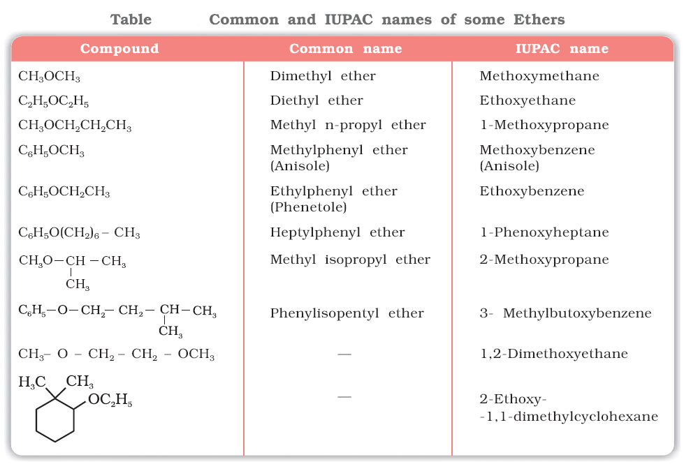

Q.



***Preparation of Alcohols***

***1. From alkenes***

(i) *By acid catalysed hydration*: Alkenes react with water in the presence of acid as catalyst to form alcohols. In case of unsymmetrical alkenes, the addition reaction takes place in accordance with Markovnikov’s rule





**(ii) *By hydroboration–oxidation*:** Diborane (BH3)2 reacts with alkenes to give trialkyl boranes as addition product. This is oxidised to alcohol by hydrogen peroxide in the presence of aqueous sodium hydroxide.



The addition of borane to the double bond takes place in such a manner that the boron atom gets attached to the sp2 carbon carrying greater number of hydrogen atoms. The alcohol so formed looks as if it has been formed by the addition of water to the alkene in a way opposite to the Markovnikov’s rule.

***2. From carbonyl compounds***

(i) *By reduction of aldehydes and ketones*: Aldehydes and ketones are reduced to the corresponding alcohols by addition of hydrogen in the presence of catalysts (catalytic hydrogenation). The usual catalyst is a finely divided metal such as platinum, palladium or nickel. It is also prepared by treating aldehydes and ketones with sodium borohydride (NaBH4) or lithium

aluminium hydride (LiAlH4).



*(ii) By reduction of carboxylic acids and esters*: Carboxylic acids are reduced to primary alcohols in excellent yields by lithium aluminium hydride, a strong reducing agent.



***3. From Grignard reagents***

Alcohols are produced by the reaction of Grignard reagents with aldehydes and ketones. The first step of the reaction is the nucleophilic addition of Grignard reagent to the carbonyl group to form an adduct. Hydrolysis of the adduct yields an alcohol.



The overall reactions using different aldehydes and ketones are as follows:



Q **(NCERT)**



**Preparation of Phenols**

***1. From haloarenes***



***2. From benzenesulphonic acid***



***3. From diazonium salts***



***4. From cumene***

Phenol is manufactured from the hydrocarbon, cumene. Cumene (isopropylbenzene) is oxidised in the presence of air to cumene hydroperoxide. It is converted to phenol and acetone by treating it with dilute acid.



Q



**(NCERT)**

Q



**(NCERT)**

**Physical Properties**

**Boiling Points**

The boiling points of alcohols and phenols increase with increase in the number of carbon atoms (increase in van der Waals forces). In alcohols, the boiling points decrease with increase of branching in carbon chain (because of decrease in van der Waals forces with decrease in surface area).

The –OH group in alcohols and phenols is involved in intermolecular hydrogen bonding.



**Solubility**

Solubility of alcohols and phenols in water is due to their ability to form hydrogen bonds with water molecules as shown. The solubility decreases with increase in size of alkyl/aryl (hydrophobic) groups. Several of the lower molecular mass alcohols are miscible with water in all proportions.

Q



**(NCERT)**

**Chemical Reactions**

Alcohols are versatile compounds. They react both as nucleophiles and electrophiles. The bond between O–H is broken when alcohols react as nucleophiles.



Based on the cleavage of O–H and C–O bonds, the reactions of alcohols and phenols may be divided into two groups:

**(a) Reactions involving cleavage of O–H bond**

***1. Acidity of alcohols and phenols***

*(i) Acidity of alcohols:* The acidic character of alcohols is due to the polar nature of O–H bond. An electron-releasing group (–CH3, –C2H5) increases electron density on oxygen tending to decrease the polarity of O-H bond. This decreases the acid strength. For this reason, the acid strength of alcohols decreases in the following order:



*(ii) Acidity of phenols:* The hydroxyl group, in phenol is directly attached to the *sp2* hybridised carbon of benzene ring which acts as an electron withdrawing group. Due to this, the charge distribution in phenol molecule, as depicted in its resonance structures, causes the oxygen of –OH group to be positive .



Phenols are stronger acids than alcohols and water.



Due to the higher electronegativity of *sp*2 hybridised carbon of phenol to which –OH is attached, electron density decreases on oxygen. This increases the polarity of O–H bond and results in an increase in ionisation of phenols than that of alcohols.

Alkoxide and phenoxide ions

In alkoxide ion, the negative charge is localised on oxygen while in phenoxide ion, the charge is delocalised. The delocalisation of negative charge (structures I-V) makes phenoxide ion more stable and favours the ionisation of phenol. Although there is also charge delocalisation in phenol, its resonance structures have charge separation due to which the phenol molecule is less stable than phenoxide ion.



In substituted phenols, the presence of electron withdrawing groups such as nitro group, enhances the acidic strength of phenol. This effect is more pronounced when such a group is present at *ortho* and *para* positions. It is due to the effective delocalisation of negative charge in phenoxide ion. On the other

hand, electron releasing groups, such as alkyl groups, in general, do not favour the formation of phenoxide ion resulting in decrease in acid strength. Cresols, for example, are less acidic than phenol.

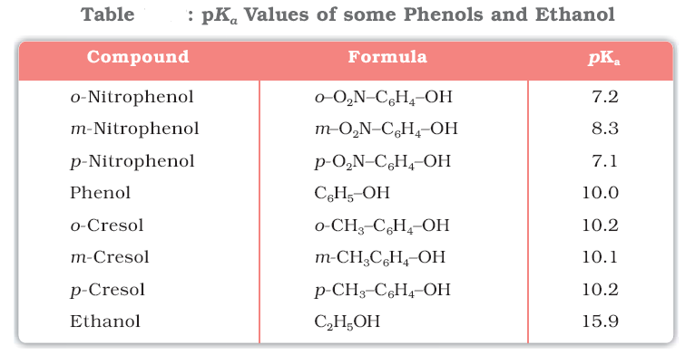

Q.



**(NCERT)**

***2. Esterification***

Alcohols and phenols react with carboxylic acids, acid chlorides and acid anhydrides to form esters.



The introduction of acetyl (CH3CO) group in alcohols or phenols is known as acetylation. Acetylation of salicylic acid produces aspirin.



**(b) Reactions involving cleavage of carbon – oxygen (C–O) bond in alcohols**

***1. Reaction with hydrogen halides:***

***2. Reaction with phosphorus trihalides:***

***3. Dehydration:***

Alcohols undergo dehydration (removal of a molecule of water) to form alkenes on treating with a protic acid e.g., concentrated H2SO4 or H3PO4, or catalysts such as anhydrous zinc chloride or alumina.



The relative ease of dehydration of alcohols follows the following order:





***4. Oxidation:***

Oxidation of alcohols involves the formation of a carbonoxygen double bond with cleavage of an O-H and C-H bonds.



Strong oxidising agents such as acidified potassium permanganate are used for getting carboxylic acids from alcohols directly. CrO3 in anhydrous medium is used as the oxidising agent for the isolation of aldehydes.



A better reagent for oxidation of primary alcohols to aldehydes in good yield is pyridinium chlorochromate (PCC).



Secondary alcohols are oxidised to ketones by chromic anhydride (CrO3).



When the vapours of a primary or a secondary alcohol are passed over heated copper at 573 K, dehydrogenation takes place and an aldehyde or a ketone is formed while tertiary alcohols undergo dehydration.



**(c) Reactions of phenols**

***1. Electrophilic aromatic substitution***

The –OH group attached to the benzene ring activates it towards electrophilic substitution. Also, it directs the incoming group to *ortho* and *para* positions in the ring as these positions become electron rich due to the resonance effect caused by –OH group.

*(i) Nitration:* With dilute nitric acid at low temperature (298 K), phenol yields a mixture of *ortho* and *para* nitrophenols.



*(ii) Halogenation:* On treating phenol with bromine, different reaction products are formed under different experimental conditions.

(a) When the reaction is carried out in solvents of low polarity such as CHCl3 or CS2 and at low temperature, monobromophenols are formed.



(b) When phenol is treated with bromine water, 2,4,6-tribromophenol is formed as white precipitate.



Q.



(NCERT)

***2. Kolbe’s reaction***

Phenoxide ion generated by treating phenol with sodium hydroxide is even more reactive than phenol towards electrophilic aromatic substitution. Hence, it undergoes electrophilic substitution with carbon dioxide, a weak electrophile. *Ortho* hydroxybenzoic acid is formed as the main reaction product.



***3. Reimer-Tiemann reaction***

On treating phenol with chloroform in the presence of sodium hydroxide, a –CHO group is introduced at *ortho* position of benzene ring. This reaction is known as *Reimer - Tiemann reaction*. The intermediate substituted benzal chloride is hydrolysed in the presence of alkali to produce salicylaldehyde.



***4. Reaction of phenol with zinc dust***

Phenol is converted to benzene on heating with zinc dust.



***5. Oxidation***

Oxidation of phenol with chromic acid produces a conjugated diketone known as benzoquinone. In the

presence of air, phenols are slowly oxidised to dark coloured mixtures containing quinones.



Q . (NCERT)



Q. (NCERT)





Q. (NCERT)

Ethers

**Preparation of Ethers**

***1. By dehydration of alcohols***

Alcohols undergo dehydration in the presence of protic acids (H2SO4, H3PO4). The formation of the reaction product, alkene or ether depends on the reaction conditions. For example, ethanol is dehydrated to ethene in the presence of sulphuric acid at 443 K. At 413 K, ethoxyethane is the main product.



The formation of ether is a nucleophilic bimolecular reaction (SN2) involving the attack of alcohol molecule on a protonated alcohol, as indicated below:

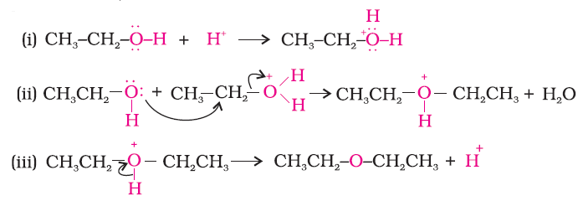

***2. Williamson synthesis***

Ethers containing substituted alkyl groups (secondary or tertiary) may also be prepared by this method. The reaction involves SN2 attack of an alkoxide ion on primary alkyl halide.





Better results are obtained if the alkyl halide is primary. In case of secondary and tertiary alkyl halides, elimination competes over substitution. If a tertiary alkyl halide is used, an alkene is the only reaction product and no ether is formed. For example, the reaction of CH3ONa with (CH3)3C–Br gives exclusively 2-methylpropene.



Q. (NCERT)



**Physical Properties**

The C-O bonds in ethers are polar and thus, ethers have a net dipole moment.

The large difference in boiling points of alcohols and ethers is due to the presence of hydrogen bonding in alcohols.

The miscibility of ethers with water resembles those of alcohols of the same molecular mass. This is due to the fact that just like alcohols, oxygen of ether can also form hydrogen bonds with water

molecule.

**Chemical Reactions**

***1. Cleavage of C–O bond in ethers***

Ethers are the least reactive of the functional groups. The cleavage of C-O bond in ethers takes place under drastic conditions with excess of hydrogen halides.

Alkyl aryl ethers are cleaved at the alkyl-oxygen bond due to the more stable aryl-oxygen bond. The reaction yields phenol and alkyl halide.





However, when one of the alkyl group is a tertiary group, the halide formed is a tertiary halide.







Q.

***2. Electrophilic substitution***

The alkoxy group (-OR) is *ortho*, *para* directing and activates the aromatic ring towards electrophilic substitution in the same way as in phenol.



(i) *Halogenation*:



(ii) *Friedel-Crafts reaction*:



(iii) *Nitration*:



Q. Write the reactions of Williamson synthesis of 2-ethoxy-3-methylpentane starting from ethanol and 3-methylpentan-2-ol. **(NCERT)**

Q.



**(NCERT)**

Q. **(NCERT)**



# NCERT Exercise



Q 1.

Q.



**Q.4** Explain why propanol has higher boiling point than that of the hydrocarbon, butane?

**Q.5** Alcohols are comparatively more soluble in water than hydrocarbons of comparable molecular masses. Explain this fact.

**Q.6** What is meant by hydroboration-oxidation reaction? Illustrate it with an example.

**Q.7** Give the structures and IUPAC names of monohydric phenols of molecular formula, C7H8O.

**Q.8** While separating a mixture of *ortho* and *para* nitrophenols by steam distillation, name the isomer which will be steam volatile. Give reason.

**Q.9** Give the equations of reactions for the preparation of phenol from cumene.

**Q.10** Write chemical reaction for the preparation of phenol from chlorobenzene.

**Q.11** Write the mechanism of hydration of ethene to yield ethanol.

**Q.12** You are given benzene, conc. H2SO4 and NaOH. Write the equations for the preparation of phenol using these reagents.

**Q.13** Show how will you synthesise:

(i) 1-phenylethanol from a suitable alkene.

(ii) cyclohexylmethanol using an alkyl halide by an SN2 reaction.

(iii) pentan-1-ol using a suitable alkyl halide?

**Q.14** Give two reactions that show the acidic nature of phenol. Compare acidity of phenol with that of ethanol.

**Q.15** Explain why is *ortho* nitrophenol more acidic than *ortho* methoxyphenol ?

**Q.16** Explain how does the –OH group attached to a carbon of benzene ring activate it towards electrophilic substitution?

**Q.17** Give equations of the following reactions:

(i) Oxidation of propan-1-ol with alkaline KMnO4 solution.

(ii) Bromine in CS2 with phenol.

(iii) Dilute HNO3 with phenol.

(iv) Treating phenol wih chloroform in presence of aqueous NaOH.

**Q.18** Explain the following with an example.

(i) Kolbe’s reaction.

(ii) Reimer-Tiemann reaction.

(iii) Williamson ether synthesis.

(iv) Unsymmetrical ether.

**Q.19** Write the mechanism of acid dehydration of ethanol to yield ethene.

**Q.20** How are the following conversions carried out?

(i) Propene → Propan-2-ol.

(ii) Benzyl chloride → Benzyl alcohol.

(iii) Ethyl magnesium chloride → Propan-1-ol.

(iv) Methyl magnesium bromide → 2-Methylpropan-2-ol.

**Q.21** Name the reagents used in the following reactions:

(i) Oxidation of a primary alcohol to carboxylic acid.

(ii) Oxidation of a primary alcohol to aldehyde.

(iii) Bromination of phenol to 2,4,6-tribromophenol.

(iv) Benzyl alcohol to benzoic acid.

(v) Dehydration of propan-2-ol to propene.

(vi) Butan-2-one to butan-2-ol.

**Q.22** Give reason for the higher boiling point of ethanol in comparison to methoxymethane.

Q



**Q.24** Write the names of reagents and equations for the preparation of the following ethers by Williamson’s synthesis:

(i) 1-Propoxypropane (ii) Ethoxybenzene (iii) 2-Methoxy-2-methylpropane (iv) 1-Methoxyethane

**Q.25** Illustrate with examples the limitations of Williamson synthesis for the preparation of certain types of ethers.

**Q.26** How is 1-propoxypropane synthesised from propan-1-ol? Write mechanism of this reaction.

**Q.27** Preparation of ethers by acid dehydration of secondary or tertiary alcohols is not a suitable method. Give reason.

**Q.28** Write the equation of the reaction of hydrogen iodide with:

(i) 1-propoxypropane (ii) methoxybenzene and (iii) benzyl ethyl ether.

**Q.29** Explain the fact that in aryl alkyl ethers (i) the alkoxy group activates the benzene ring towards electrophilic substitution and (ii) it directs the incoming substituents to ortho and para positions in benzene ring.

**Q.30** Write the mechanism of the reaction of HI with methoxymethane.

**Q.31** Write equations of the following reactions:

(i) Friedel-Crafts reaction – alkylation of anisole.

(ii) Nitration of anisole.

(iii) Bromination of anisole in ethanoic acid medium.

(iv) Friedel-Craft’s acetylation of anisole.

**Q.32** Show how would you synthesise the following alcohols from appropriate alkenes?



Q



## Acyl Groups

In aldehydes, the carbonyl group is bonded to a carbon and hydrogen while in the ketones, it is bonded to two carbon atoms. The carbonyl compounds in which carbonyl group is bonded to oxygen are known as carboxylic acids, and their derivatives (e.g. esters, anhydrides) while in compounds where carbon is attached to nitrogen and to halogens are called amides and acyl halides respectively.





Nomenclature and Structure of Carbonyl Group

Aldehydes and ketones are the simplest and most important carbonyl compounds.

***(a) Common names***

Aldehydes and ketones are often called by their common names instead of IUPAC names. The common names of most aldehydes are derived from the common names of the corresponding carboxylic acids by replacing the ending –*ic* of acid with aldehyde.



The common names of ketones are derived by naming two alkyl or aryl groups bonded to the carbonyl group.



***(b) IUPAC names***

The IUPAC names of open chain aliphatic aldehydes and ketones are derived from the names of the corresponding alkanes by replacing the ending –*e* with –*al* and –*one* respectively. In case of aldehydes the longest carbon chain is numbered starting from the carbon of the aldehyde group while in case of ketones the numbering begins from the end nearer to the carbonyl group.



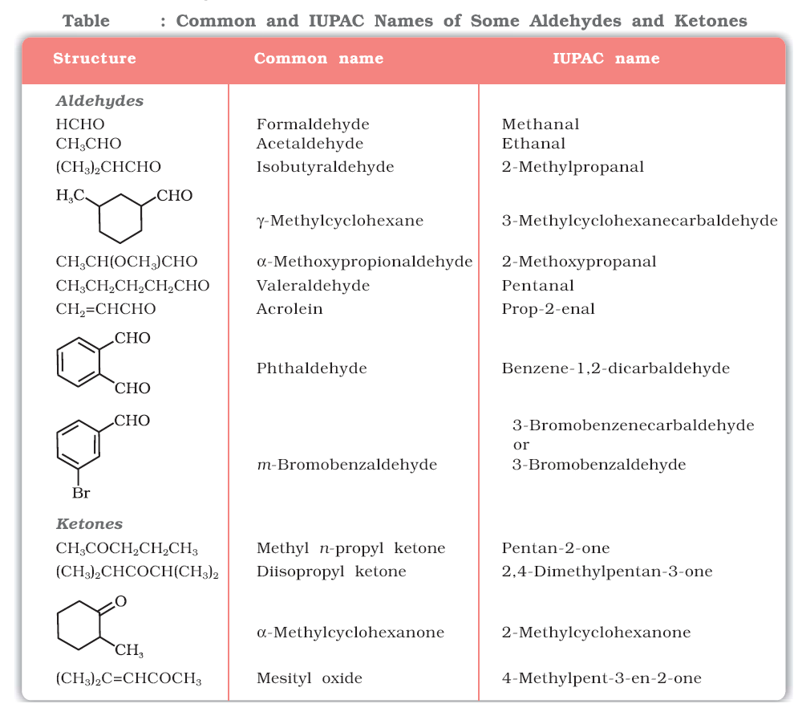

**Structure of the Carbonyl Group**

The carbonyl carbon atom is *sp2*-hybridised and forms three sigma (σ) bonds. The fourth valence electron of carbon remains in its *p*-orbital and forms a π-bond with oxygen by overlap with *p*-orbital of an oxygen.



Q.



Preparation of Aldehydes and Ketones

***1. By oxidation of alcohols***

***2. By dehydrogenation of alcohols***

***3. From hydrocarbons***

(*i*) *By ozonolysis of alkenes:* As we know, ozonolysis of alkenes followed by reaction with zinc dust and water gives aldehydes, ketones or a mixture of both depending on the substitution pattern of the alkene.

(*ii*) *By hydration of alkynes:* Addition of water to ethyne in the presence of H2SO4 and HgSO4 gives acetaldehyde. All other alkynes give ketones in this reaction .

**Preparation of Aldehydes**

***1. From acyl chloride (acid chloride)***

Acyl chloride (acid chloride) is hydrogenated over catalyst, palladium on barium sulphate. This reaction is called **Rosenmund reduction**.



***2. From nitriles and esters***

Nitriles are reduced to corresponding imine with stannous chloride in the presence of hydrochloric acid, which on hydrolysis give corresponding aldehyde.



This reaction is called **Stephen** reaction**.**

Alternatively, nitriles are selectively reduced by diisobutylaluminium hydride, (DIBAL-H) to imines followed by hydrolysis to aldehydes:



***3. From hydrocarbons***

Aromatic aldehydes (benzaldehyde and its derivatives) are prepared from aromatic hydrocarbons by the following methods:

*(i) By oxidation of methylbenzene*

Strong oxidising agents oxidise toluene and its derivatives to benzoic acids. However, it is possible to stop the oxidation at the aldehyde stage with suitable reagents that convert the methyl group to an intermediate that is difficult to oxidise further.

(a) Use of chromyl chloride (CrO2Cl2): Chromyl chloride oxidizes methyl group to a chromium complex, which on hydrolysis gives corresponding benzaldehyde.



This reaction is called **Etard reaction**.

(b) Use of chromic oxide (CrO3): Toluene or substituted toluene is converted to benzylidene diacetate on treating with chromic oxide in acetic anhydride. The benzylidene diacetate can be hydrolysed to corresponding benzaldehyde with aqueous acid.



*(ii) By side chain chlorination followed by hydrolysis*

Side chain chlorination of toluene gives benzal chloride, which on hydrolysis gives benzaldehyde. This is a commercial method of manufacture of benzaldehyde.



*(iii) By Gatterman – Koch reaction*

When benzene or its derivative is treated with carbon monoxide and hydrogen chloride in the presence of anhydrous aluminium chloride or cuprous chloride, it gives benzaldehyde or substituted benzaldehyde.



This reaction is known as **Gatterman-Koch** reaction.

**Preparation of Ketones**

***1. From acyl chlorides***

Treatment of acyl chlorides with dialkylcadmium, prepared by the reaction of cadmium chloride with Grignard reagent, gives ketones.



***2. From nitriles***

Treating a nitrile with Grignard reagent followed by hydrolysis yields a ketone.



***3. From benzene or substituted benzenes***

When benzene or substituted benzene is treated with acid chloride in the presence of anhydrous aluminium chloride, it affords the corresponding ketone. This reaction is known as **Friedel-Crafts acylation reaction**.



***Q.***



***Q.***

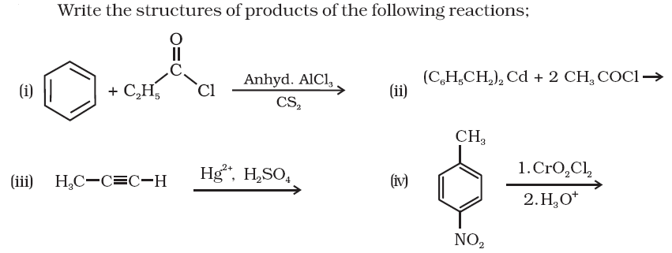

Physical Properties

Methanal is a gas at room temperature. Ethanal is a volatile liquid. Other aldehydes and ketones are liquid or solid at room temperature. The boiling points of aldehydes and ketones are higher than hydrocarbons and ethers of comparable molecular masses. It is due to weak molecular association in aldehydes and ketones arising out of the dipole-dipole interactions. Also, their boiling points are lower than those of alcohols of similar molecular masses due to absence of intermolecular hydrogen bonding.

All aldehydes and ketones are fairly soluble in organic solvents like benzene, ether, methanol, chloroform, etc. The lower aldehydes have sharp pungent odours. As the size of the molecule increases, the odour becomes less pungent and more fragrant.

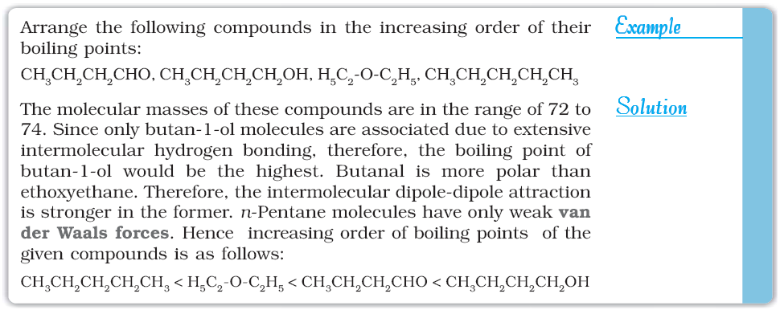

Q.



Chemical Reactions

1. Nucleophilic addition reactions

*(i) Mechanism of nucleophilic addition reactions*

A nucleophile attacks the electrophilic carbon atom of the polar carbonyl group from a direction approximately perpendicular to the plane of *sp2* hybridised orbitals of carbonyl carbon .The hybridisation of carbon changes from *sp2* to *sp3* in this process, and a tetrahedral alkoxide intermediate is produced.

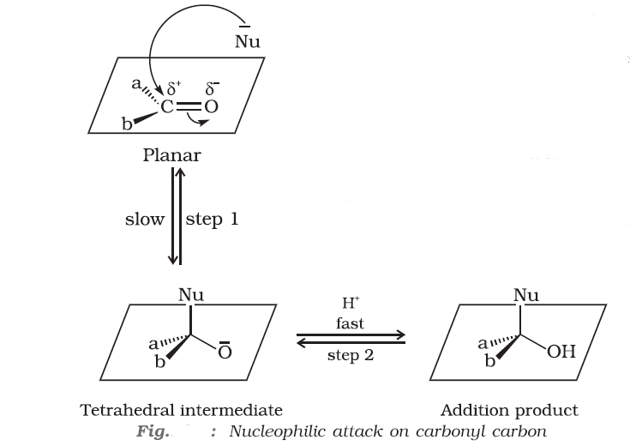

*(ii) Reactivity*

Aldehydes are generally more reactive than ketones in nucleophilic addition reactions due to steric and electronic reasons. Sterically, the presence of two relatively large substituents in ketones hinders the approach of nucleophile to carbonyl carbon than in aldehydes having only one such substituent. Electronically, aldehydes are more reactive than ketones because two alkyl groups reduce the electrophilicity of the carbonyl more effectively than in former.

Q. Would you expect benzaldehyde to be more reactive or less reactive in nucleophilic addition reactions than propanal? Explain your answer.

*(iii) Some important examples of nucleophilic addition and nucleophilic addition-elimination reactions:*

(a) *Addition of hydrogen cyanide (HCN)*:



(b) *Addition of sodium hydrogensulphite:*



(d) *Addition of alcohols:*



(e) *Addition of ammonia and its derivatives*:



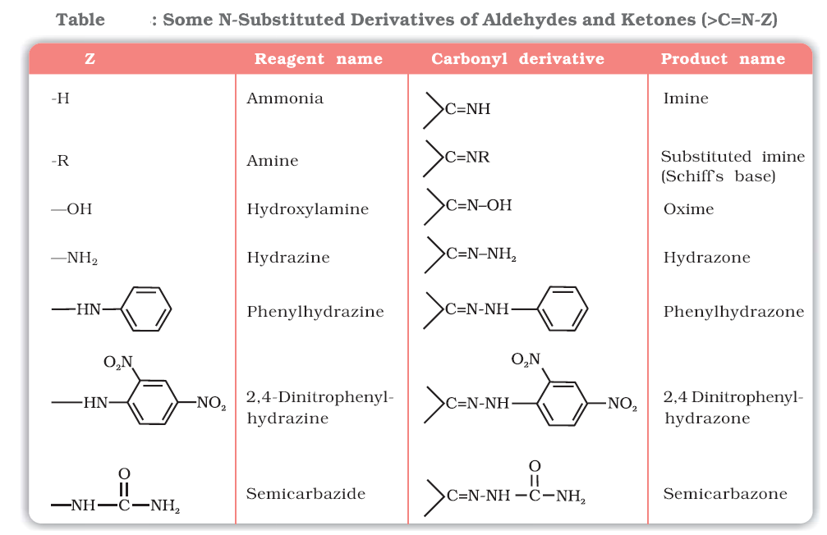

***2. Reduction***

*(i) Reduction to alcohols:*

Aldehydes and ketones are reduced to primary and secondary alcohols respectively by sodium borohydride (NaBH4) or lithium aluminium hydride (LiAlH4) as well as by catalytic hydrogenation.

(*ii*) *Reduction to hydrocarbons:*

The carbonyl group of aldehydes and ketones is reduced to CH2 group on treatment with zincamalgam

and concentrated hydrochloric acid[**Clemmensen reduction**] or with hydrazine followed by heating with sodium or potassium hydroxide in high boiling solvent such as ethylene glycol (**Wolff-Kishner reduction**).



***3. Oxidation***

Aldehydes are easily oxidised to carboxylic acids on treatment with common oxidising agents like nitric acid, potassium permanganate, potassium dichromate, etc. Even mild oxidising agents, mainly Tollens’ reagent and Fehlings’ reagent also oxidise aldehydes.



Ketones are generally oxidised under vigorous conditions, i.e., strong oxidising agents and at elevated temperatures. Their oxidation involves carbon-carbon bond cleavage to afford a mixture of carboxylic

acids having lesser number of carbon atoms than the parent ketone.



The mild oxidising agents given below are used to distinguish aldehydes from ketones:

*(i) Tollens’ test:*

On warming an aldehyde with freshly prepared ammoniacal silver nitrate solution (Tollens’ reagent), a bright silver mirror is produced due to the formation of silver metal. The aldehydes are oxidised to corresponding carboxylate anion.



*(ii) Fehling’s test:*

On heating an aldehyde with Fehling’s reagent, a reddish brown precipitate is obtained. Aldehydes are oxidised to corresponding carboxylate anion. Aromatic aldehydes do not respond to this test.



*(iii) Oxidation of methyl ketones by haloform reaction*:



Q. An organic compound (A) with molecular formula C8H8O forms an orange-red precipitate with 2,4-DNP reagent and gives yellow precipitate on heating with iodine in the presence of sodium hydroxide. It neither reduces Tollens’ or Fehlings’ reagent, nor does it decolourise bromine water or Baeyer’s reagent. On drastic oxidation with chromic acid, it gives a carboxylic acid (B) having molecular formula C7H6O2. Identify the compounds (A) and (B) and explain the reactions involved.

***4. Reactions due to a-hydrogen***

The acidity of α-hydrogen atoms of carbonyl compounds is due to the strong electron withdrawing effect of the carbonyl group and resonance stabilisation of the conjugate base.



*(i) Aldol condensation:* Aldehydes and ketones having at least one α-hydrogen undergo a reaction in the presence of dilute alkali as catalyst to form β-hydroxy aldehydes (aldol) or β-hydroxy ketones (ketol), respectively. This is known as **Aldol reaction.**



***5. Other reactions***

(*i*) *Cannizzaro reaction:*

Aldehydes which do not have an α-hydrogen atom, undergo self oxidation and reduction (disproportionation) reaction on treatment with concentrated alkali. In this reaction, one molecule of the aldehyde is reduced to alcohol while another is oxidised to carboxylic acid salt.



(*ii*) *Electrophilic substitution reaction*:

Aromatic aldehydes and ketones undergo electrophilic substitution at the ring in which the carbonyl group acts as a deactivating and *meta*-directing group.



Q.

Q.



Nomenclature and Structure of Carboxyl Group

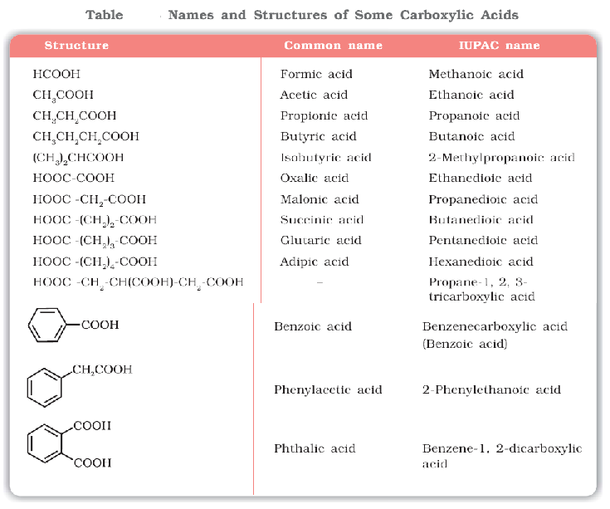

Q.



Methods of Preparation of Carboxylic Acids

***1. From primary alcohols and aldehydes***



***2. From alkylbenzenes***

Aromatic carboxylic acids can be prepared by vigorous oxidation of alkyl benzenes with chromic acid or acidic or alkaline potassium permanganate. The entire side chain is oxidised to the carboxyl group irrespective of length of the side chain. Primary and secondary alkyl groups are oxidised in this manner while tertiary group is not affected. Suitably substituted alkenes are also oxidised to carboxylic acids with these oxidising reagents.



***3. From nitriles and amides***

Nitriles are hydrolysed to amides and then to acids in the presence of H+ or OH− as catalyst. Mild reaction conditions are used to stop the reaction at the amide stage.



***4. From Grignard reagents***

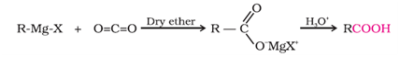

***5. From acyl halides and anhydrides***



***6. From esters***

Acidic hydrolysis of esters gives directly carboxylic acids while basic hydrolysis gives carboxylates, which on acidification give corresponding carboxylic acids.



Q.



Q.



Physical Properties

Aliphatic carboxylic acids upto nine carbon atoms are colourless liquids at room temperature with unpleasant odours. The higher acids are wax like solids and are practically odourless due to their low volatility. Carboxylic acids are higher boiling liquids than aldehydes, ketones and even alcohols of comparable molecular masses. This is due to more extensive association of carboxylic acid molecules through intermolecular hydrogen bonding. The hydrogen bonds are not broken completely even in the vapour phase. In fact, most carboxylic acids exist as dimer in the vapour phase or in the aprotic solvents.

Simple aliphatic carboxylic acids having upto four carbon atoms are miscible in water due to the formation of hydrogen bonds with water. The solubility decreases with increasing number of carbon atoms. Higher carboxylic acids are practically insoluble in water due to the increased hydrophobic interaction of hydrocarbon part. Benzoic acid, the simplest aromatic carboxylic acid is nearly insoluble in cold water. Carboxylic acids are also soluble in less polar organic solvents like benzene, ether, alcohol, chloroform, etc.



Chemical Reactions

**Reactions Involving Cleavage of O–H Bond**

***Acidity***

*Reactions with metals and alkalies*



Carboxylic acids are weaker than mineral acids, but they are stronger acids than alcohols and many simple phenols (p*Ka* is ~16 for ethanol and 10 for phenol). In fact, carboxylic acids are amongst the most acidic organic compounds.

*Effect of substituents on the acidity of carboxylic acids:*

Electron withdrawing groups increase the acidity of carboxylic acids by stabilising the conjugate base through delocalisation of the negative charge by inductive and/or resonance effects. Conversely, electron donating groups decrease the acidity by destabilising the conjugate base.





**Reactions Involving Cleavage of C–OH Bond**

***1. Formation of anhydride***



***2. Esterification***





***3. Reactions with PCl5, PCl3 and SOCl2***



***4. Reaction with ammonia***



**Reactions Involving –COOH Group**

***1. Reduction***



***2. Decarboxylation***

Carboxylic acids lose carbon dioxide to form hydrocarbons when their sodium salts are heated with sodalime (NaOH and CaO in the ratio of 3 : 1). The reaction is known as decarboxylation.



Alkali metal salts of carboxylic acids also undergo decarboxylation on electrolysis of their aqueous solutions and form hydrocarbons having twice the number of carbon atoms present in the alkyl group of the acid. The reaction is known as **Kolbe electrolysis.**

**Substitution Reactions in the Hydrocarbon Part**

***1. Halogenation***

Carboxylic acids having an α-hydrogen are halogenated at the α-position on treatment with chlorine or bromine in the presence of small amount of red phosphorus to give α-halocarboxylic acids. The reaction is known as **Hell-Volhard-Zelinsky reaction.**



***2. Ring substitution***

Aromatic carboxylic acids undergo electrophilic substitution reactions in which the carboxyl group acts as a deactivating and meta-directing group. They however, do not undergo **Friedel-Crafts reaction** (because the carboxyl group is deactivating and the catalyst aluminium chloride (Lewis acid) gets bonded to the carboxyl group).



Q.



NCERT Exercises

Q2.





Q3.

Q4.





Q5.

Q6.



Q7.



Q8.





Q9.

Q10.





Q11.

Q12.



Q13. Give simple chemical tests to distinguish between the following pairs of compounds.

(i) Propanal and Propanone (ii) Acetophenone and Benzophenone

(iii) Phenol and Benzoic acid (iv) Benzoic acid and Ethyl benzoate

(v) Pentan-2-one and Pentan-3-one (vi) Benzaldehyde and Acetophenone

(vii) Ethanal and Propanal

Q14.



Q15.



Q17. Complete each synthesis by giving missing starting material, reagent or products



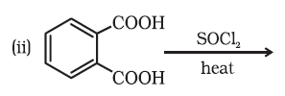



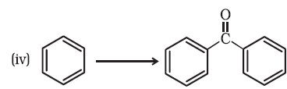















Q18.



Q19.





Q20.

## Amines

Amines constitute an important class of organic compounds derived by replacing one or more hydrogen atoms of ammonia molecule by alkyl/aryl group(s).

**AMINES**

Amines can be considered as derivatives of ammonia, obtained by replacement of one, two or all the three hydrogen atoms by alkyl and/or aryl groups. For example:



Structure of Amines

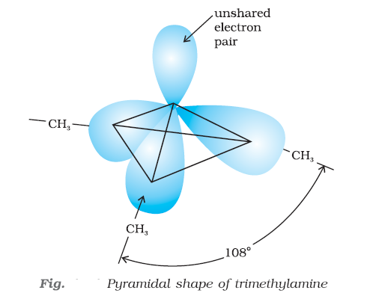

Classification

